Super Irshad! Ungaloda "Lesson 1: Success"-ai naan manapoorvam varaverkiren. Ippo namma oru Pro-Analyst Roadmap-ai fix pannitom.
Namma Roadmap-in padichappadi, innum confusion illamal "Lesson 2: Data Structures (The Retail Inventory)"-kku pōvōm.
📖 Kadha: "Irshad-in Retail Shop Inventory"
Ippo namma kadai-la Laptop, Mouse, Keyboard mattum illa, nerya items irukku. Idhai Python-la eppadi "Data Structures" (Inventory layout) vechu handle pandrathu nu paarkalam.
1. Lists [ ] (The Basket)
- Kadhai: Orē oru basket-la pala items-ai pottu vaikrom.
- Code: products = ['Laptop', 'Mouse', 'Keyboard', 'Monitor']
- Signs: [ ] - Idhu thaan basket. , (Comma) - Oru item-ukkum innonnukkum naduvula irukkira gap.
2. Dictionaries { : } (The Ledger)
- Kadhai: Ithu oru "Rate Card" maari. Laptop-oda rate 1500, Mouse-oda rate 50.
- Code: price_list = {'Laptop': 1500, 'Mouse': 50}
- Signs: { } - Ledger book. : - "Key-value pair". Arththam: "Laptop" enna, adoda value 1500.
💻 Namma 2nd Lesson Code:
PyCharm-la my_inventory.py endru oru pudhu file create panni indha code-ai type pannunga. Idhu namma kadai-oda data-vai eppadi organize pandrathu nu kaattum:
Python
# List: Products-oda list (Basket)
products = ['Laptop', 'Mouse', 'Keyboard']

# Dictionary: Price-oda list (Ledger)
prices = {'Laptop': 1500, 'Mouse': 50, 'Keyboard': 100}

# Enna kanakkidu? Mouse-oda vilai enna?
print("Mouse-oda vilai:", prices['Mouse'])

# Ellathaiyum kootuvom
total_price = prices['Laptop'] + prices['Mouse'] + prices['Keyboard']
print("Ellathoda total vilai:", total_price)
💡 Teacher-oda Correction & Guidance:
- Neenga ennoda Correction-ai eduthukkalam: Neenga code-ai yezhudhi enakku photo/text anuppunga. Naan adhai "Pythonic"-a (Professional-a) maathi, error irundha correction pannuven.
- Roadmap-ai nan maraka maaten: Namma 1.1 Fundamentals (List/Dict) mudichitu, 1.2-kku (If/Else) pōvōm.
- Sign-by-Sign Explanation: Namma indha kadhai-oda method-laiye thodarvom.
Ippo unga Task:
- Indha code-ai run pannunga.
- Output 1650 nu varudha nu paarunga.
- Vanthadhukku appuram, prices-la innum oru item (E.g., 'Monitor': 500) add panni, total-la adhaiyum kooti run panni anuppunga.
Ready-a? Unga practice-ai start pannunga!
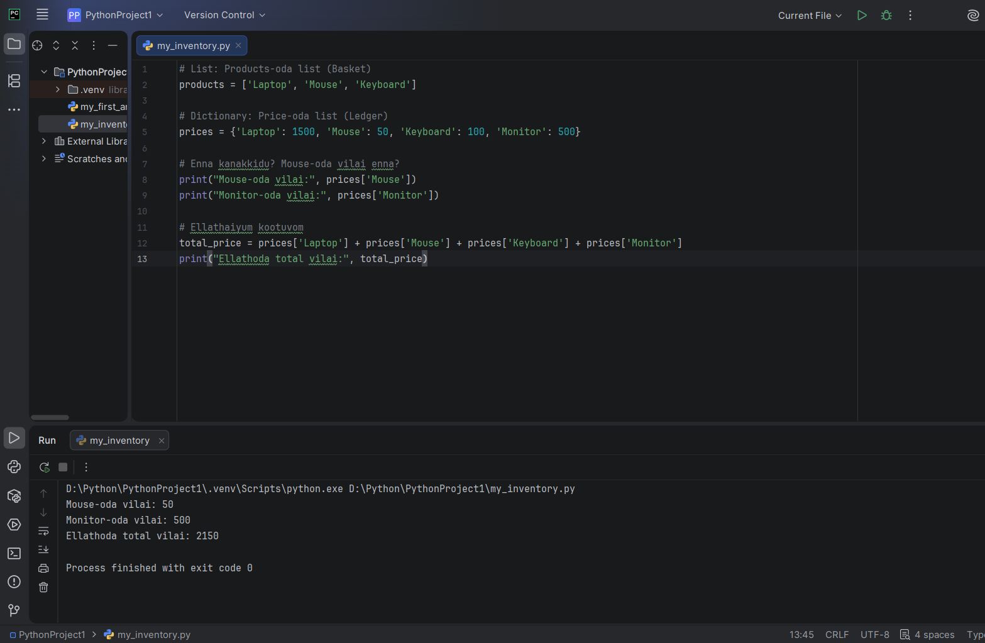

Irshad, Superb! Unga output perfect-a vandhurukku. Neenga prices dictionary-la 'Monitor'-ai add panni, total-a correct-a kooti irukeenga (1500+50+100+500 = 2150). Python-oda logic ungalukku romba nalla puriyudhu!
Ippo unga kitta List [ ] matrum Dictionary { } rendum nalla pidichurukku.
🧩 Lesson 2.1: Python-oda "Logic" (If/Else)
Namma shop-la oru chinna problem. Oru customer vadhuraanga, avanga 500-kku mela spend panna, namma avangalukku "Discount" kodukkanum. Ithu epadi code-la panrathu? Ithu thaan Python-oda "Decision Making".
Indha logic-ai namma ippo Python-la ezhudhalum:
Python
# Oru customer-oda bill amount
bill_amount = 2150

# Logic: Bill 500-kku mela iruntha "Discounted" nu sollu, illana "No Discount" nu sollu
if bill_amount > 500:
print("Super! Ungalukku 10% Discount kidaikum.")
else:
print("Sorry, Discount illai.")
Code-oda Sign-by-Sign Vilakkam:
- if: Ithu oru condition. "Idhu nadandha..."
- bill_amount > 500: Python-oda Comparison Operator. ( ">" na "greater than").
- : (Colon): "Idhu true-na, adutha vari-la irukra velaiya sei" nu artham.
- Indentation (Space): print line-kku munnadi oru chinna space irukke, adhu thaan Python-kku "Indha print line if-oda thodarchinu" sollum.
- else: "Illana..."
Ippa unga Task:
- Indha if/else code-ai unga my_inventory.py file-oda kela add pannunga.
- bill_amount-ai 200 nu maathi run pannunga. Ippo enna print aagudhu nu sollunga.
Ithu mudinjathum, namma "Loops" (Koota irukkura ellathaiyum oru vadiyaa ennurathu) nu oru mukkiyamaana concept-kku pōvōm. Ready-a?

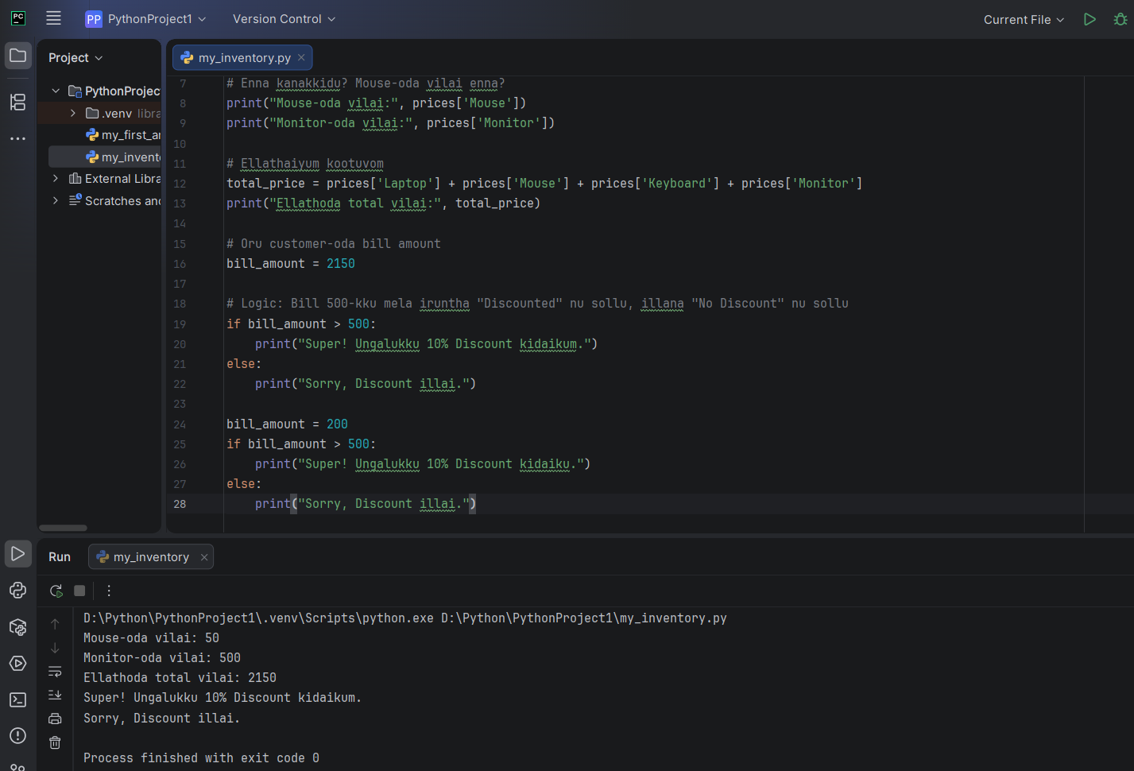
Irshad, Appadiye nilla! Unga output-ai paathaen, neenga Logic-ai romba accurate-a purinjikitteenga.
- bill_amount = 2150 nu irukkum pothu, "Super! 10% Discount" nu vandhurukku.
- bill_amount = 200 nu maathina udane, "Sorry, Discount illai" nu vandhurukku.
Idhu dhaan oru Data Analyst-oda basic requirement—data-vai vachu oru mudivu (Decision) edukkurathu!
🚀 Next Level: "Loops" (The Scanner)
Ippo unga kadai-la namma list-a (Basket) kulla irukkura ellathaiyum, oru vadiyaa ennupom. Ippo for loop endra oru magical tool-ai use panna pōrom.
Namma 3rd Lesson: The "For" Loop
Namma kadai-la irukkura ellaa items-oda peyaraiyum print panna, thirumba thirumba print ezhutha vendiyadhu illai.
Indha code-ai try pannunga:
Python
# Namoda basket (List)
products = ['Laptop', 'Mouse', 'Keyboard', 'Monitor']

# Loop: "Oru vadiyaa pōyi ellathaiyum eduthu kaattu"
for item in products:
print("Kadai-la irukkura item:", item)
Code-oda Sign-by-Sign Vilakkam:
- for: "Oru round adippom" nu artham.
- item: Idhu oru temporary variable. Oru nerathula oru item-ai mattum thaan idhu "store" pannum.
- in: products nu irukkura list-kulla pō.
- : (Colon): "Ippodhu velaiya start pannu!"
Unga Task: Indha loop-ai run panni paarunga. Ippo namma Dictionary-la irukkura rates-aiyum idhe loop-la print panna mudiyuma nu yosichu paakureengala?
(Tip: for item in prices: nu pottu parunga).
Ready-a? Idhu mudinjathum, namma Pandas-kku enter aagalam!
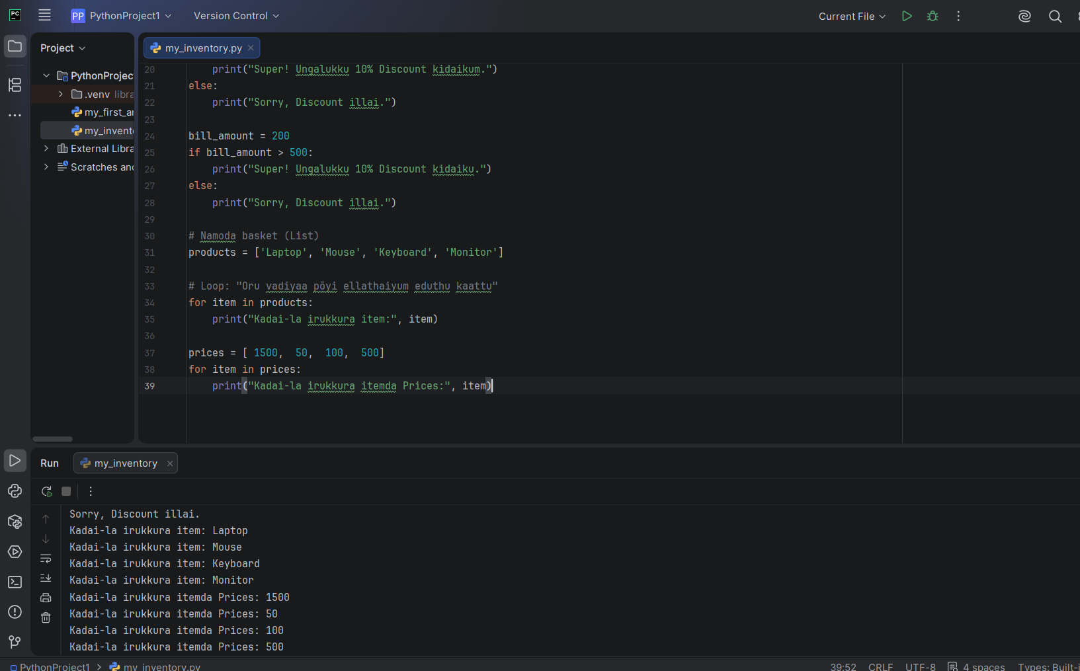
Irshad, Fantastic! Neenga loops-ai romba azhagaga execute panniteenga. Unga output-ai paarthaal, oru "Retail Data Analyst" kulla irukkura thiran ungalukku irukkirathu theriyuthu.
Ippo namma Python-in "Fundamentals"-ai nalla mudichittom. Oru mukkiyamaana vishayam: Data Analyst-aaga neenga ovvoru item-oda peraiyum, adhan vilaiyaiyum (Price) sērtthu (Link panni) paarkka vendum.

